**OOP Final Project**

**NEON – SYSTEM**

**Instructions:**

1. Ensure to add “data.txt” file in the project folder. In case, data.txt file is corrupted or data may lose due to various reasons, copy the data from “spareFile.txt” and paste in “data.txt” file. Do the same changes in “Execution File (NEON)” folder.
2. Compile and run the code (Press ctrl + F5) and wait for 2 to 3 seconds.
3. Now you can see a list of departments save in file. Use “up” key to move upward, “down” key to move downward and “ENTER” key for selection (wait for 0.5 seconds after pressing ENTER key).

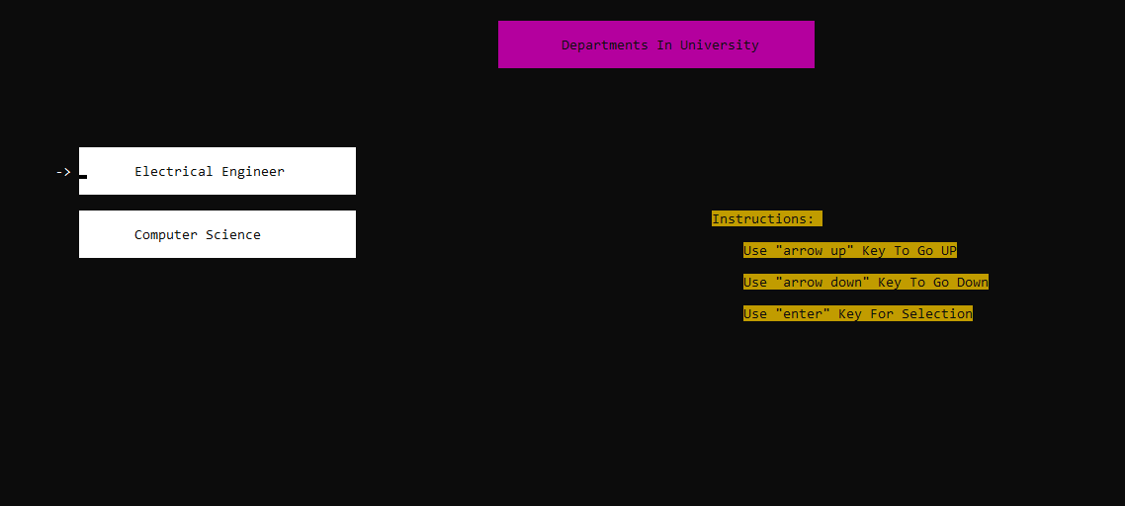

1. To continue, modes of different entities will be shown. Choose any mode (Use “ENTER” key for selection).

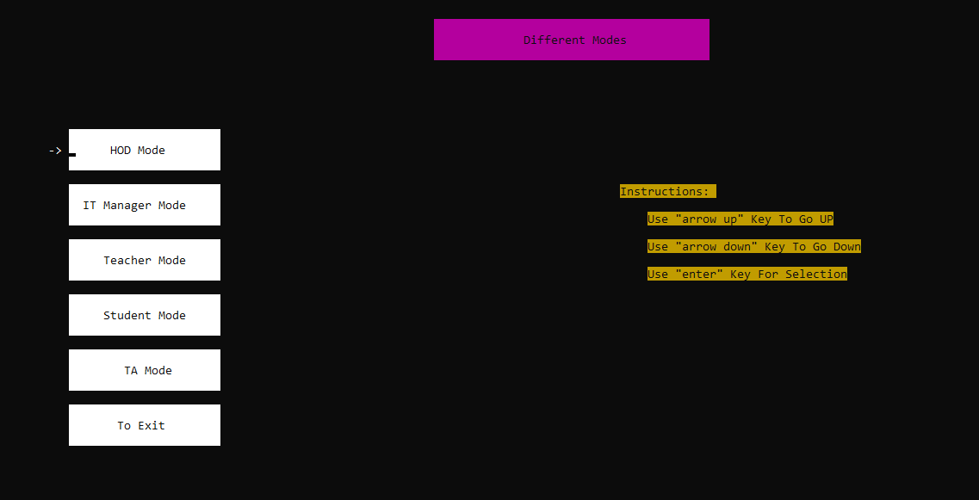

1. Enter “Username” and “Password” against their respective blocks. Some sample usernames and passwords for different modes are given below.

**For HOD)** username = "def", password = "def"

**For IT Manager)** username= "abc", password="abc"

**For Teacher)** username = "ali", password = "ali"

**For student)** username = "mno", password = "mno"

**For TA)** username= "mno", password = "mno" (TA is also a student)

After inputting both username and password, wait for 2 seconds.

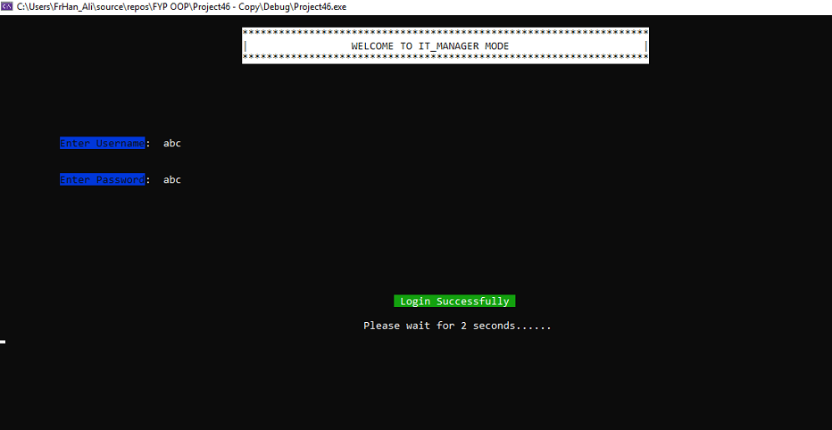

1. Now the functionalities of respective mode will appear. Use “up” key to move upward, “down” key to move downward and “ENTER” key for selection (wait for 0.5 seconds after pressing ENTER key).

**TA’s Functionalities:**

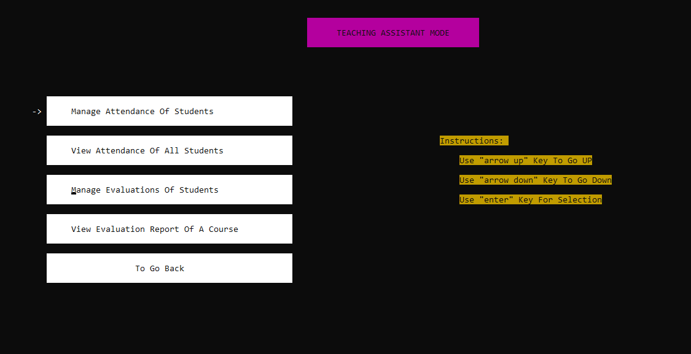

**HOD’s Functionalities:**

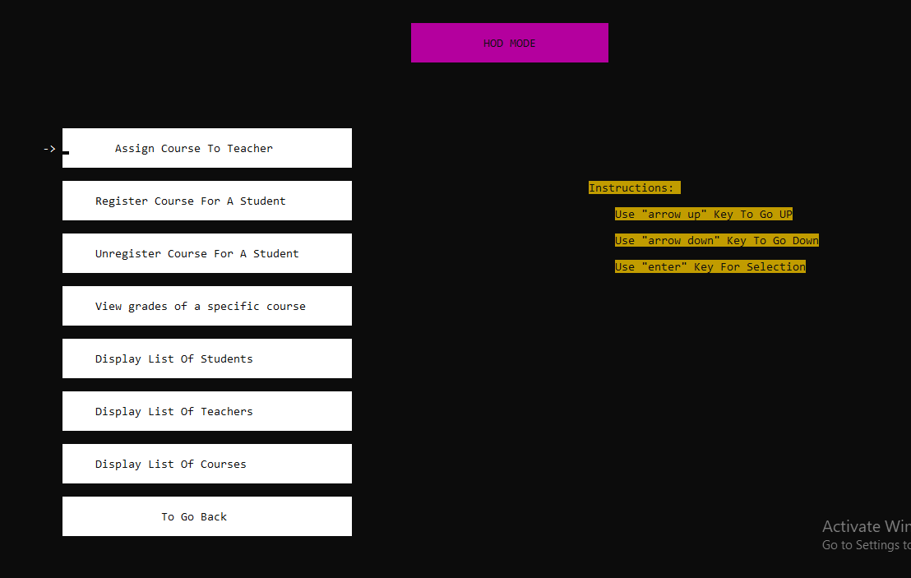

**Teacher’s Functionalities:**

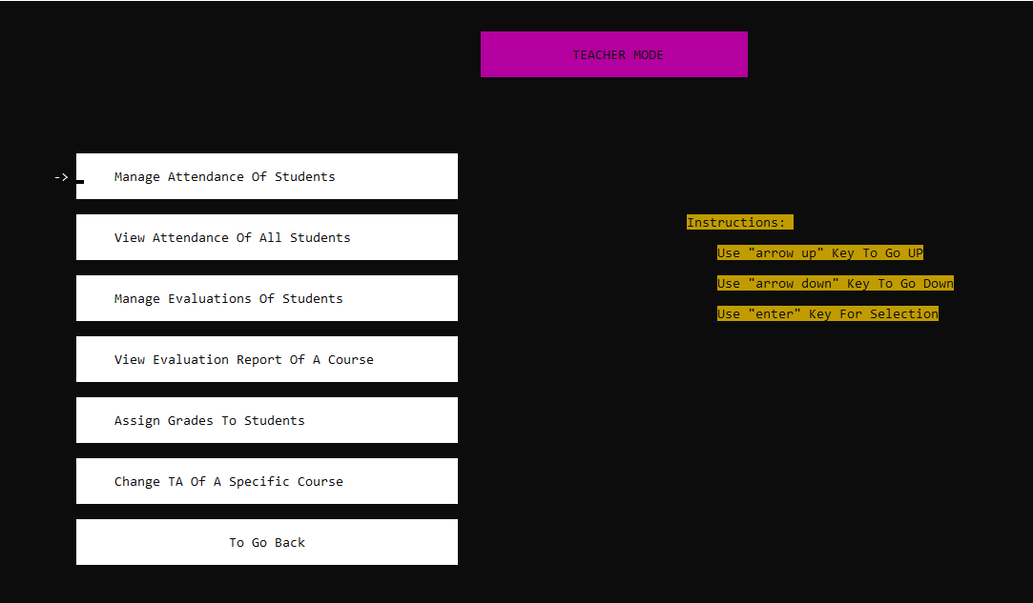

**IT Manager’s Functionalities:**

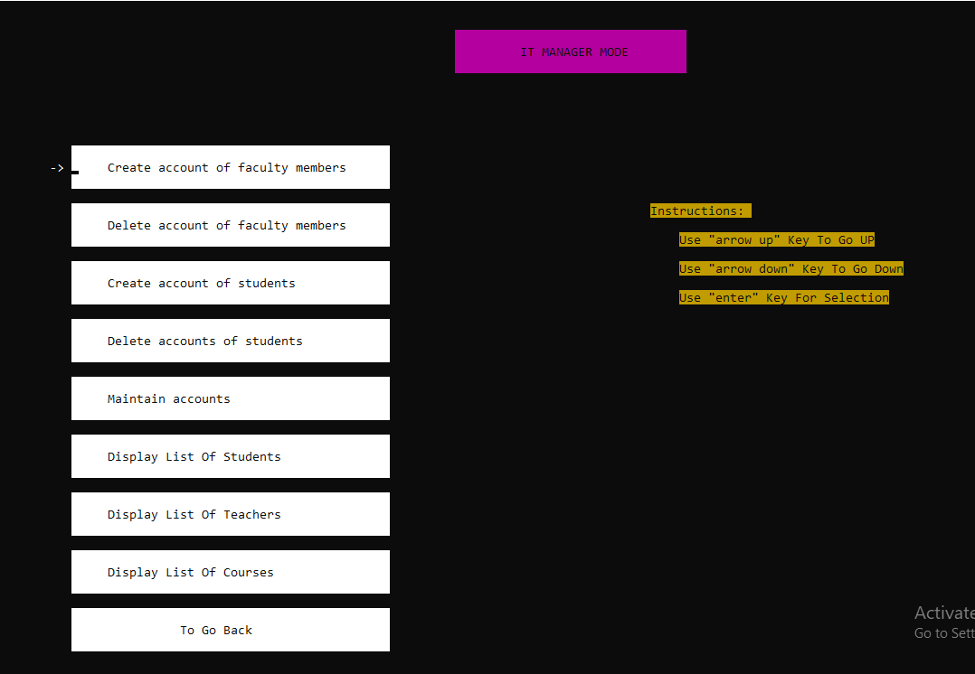

**Student’s Functionalities:**

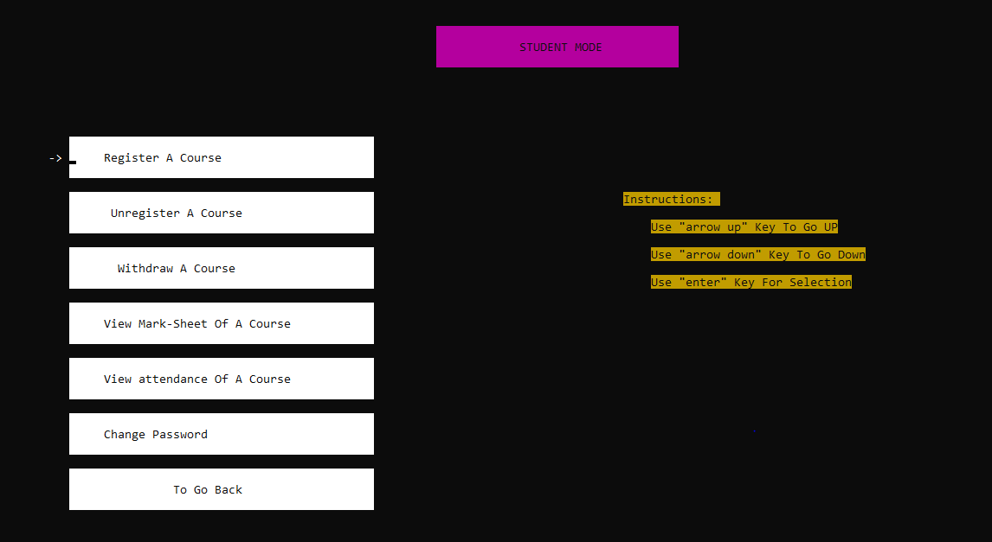

1. After performing the desirable functionalities, use “Exit” menu to exit the program. If you use cross button(x) to cancel the console screen, data will not save in file. To ensure that data is saved in file all the time, use “Exit” menu instead of cross button(x).

**THE END**